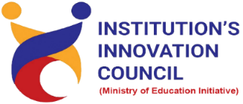
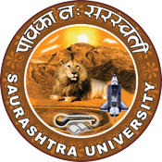

Enterpreneurial Mindset

14th August 2023
At
Seminar Hall
Department of Commerce
Saurashtra University
Rajkot

Contents
Saurashtra University – IIC 3
Event Schedule 3
Event Registration Link 3
Brief about Event 4
Key Points 4
Outcome 5
About the Speaker/Chief Guest 6
Connect Us: 8

Saurashtra University – IIC
The university is dedicated to instruction, research, and extending knowledge to the public (public service). Ministry of Education (MoE), Govt. of India has established ‘MoE’s Innovation Cell (MIC)’ to systematically foster the culture of Innovation among all Higher Education Institutions (HEIs). The primary mandate of MIC is to encourage, inspire and nurture young students by supporting them to work with new ideas and transform them into prototypes while they are informative years. Saurashtra University is one the Organization that have constituted the IIC to foster the vision of MoE and be a part for the promotion and development of innovation ecosystem.

Event Schedule

Event Registration Link

bit.ly/SUSEC-COMEN

Brief about Event
The Department of Commerce at Saurashtra University was proud to host a captivating event titled " Entrepreneurial Mindset" on August 14, 2023. This event aimed to inspire and educate students and aspiring entrepreneurs about the vital role of an entrepreneurial mindset in today's dynamic business world.
Dr. Raju M. Rathod, an esteemed expert in business management from Sardar Patel University, Vallabh Vidyanagar, graced the occasion as the guest speaker. With a wealth of knowledge and experience in entrepreneurship, Dr. Rathod provided invaluable insights into cultivating and nurturing an entrepreneurial mindset.
During the event, attendees had the opportunity to:
- Learn from an Expert: Dr. Raju M. Rathod shared his expertise and real-world experiences, shedding light on the characteristics, skills, and strategies that define a successful entrepreneur.
- Interactive Sessions: Engaging discussions and interactive sessions allowed participants to ask questions, share their thoughts, and gain a deeper understanding of the entrepreneurial mindset.
- Networking: The event facilitated networking among students, faculty, and aspiring entrepreneurs, fostering valuable connections and collaborations.
- Inspiration: Dr. Rathod's motivational talk encouraged attendees to embrace innovation, take calculated risks, and develop a resilient and adaptable mindset crucial for entrepreneurial success.
"Unlocking the Entrepreneurial Mindset" was a resounding success, leaving participants inspired and better equipped to navigate the challenges of the entrepreneurial world. The Department of Commerce at Saurashtra University remains committed to nurturing the entrepreneurial spirit within its student community, preparing them for the opportunities and challenges of tomorrow's business landscape.

Key Points

During the visit, below mentioned points were consider:
- Key characteristics of successful entrepreneurs: creativity, adaptability, and perseverance.
- Emphasis on skill development: problem-solving, leadership, and communication.
- Strategies for starting and growing a business were discussed.
- Interactive Q&A sessions allowed for deeper exploration of the entrepreneurial mindset.
- Networking opportunities fostered valuable connections.
- Motivational talk inspired innovation, risk-taking, and resilience.
- The event prepared students for future entrepreneurial challenges.

Outcome
As per the event, "Entrepreneurial Mindset" organized by the Department of Commerce at Saurashtra University on August 14, 2023, yielded significant outcomes. Attendees left with a deeper comprehension of the entrepreneurial mindset, armed with key insights into the necessary characteristics and skills for success. The event also fostered engagement through interactive discussions and Q&A sessions, enabling participants to seek guidance and clarification. Moreover, networking opportunities facilitated valuable connections and potential collaborations among students, faculty, and aspiring entrepreneurs. Dr. Raju M. Rathod's motivational address left attendees inspired to approach entrepreneurship with innovation, calculated risk-taking, and a resilient mindset. Most importantly, the event equipped students with the knowledge and confidence needed to navigate the ever-evolving challenges and opportunities in the entrepreneurial landscape, preparing them for a future filled with possibilities.

About the Speaker/Chief Guest
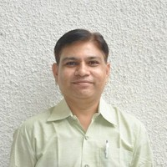

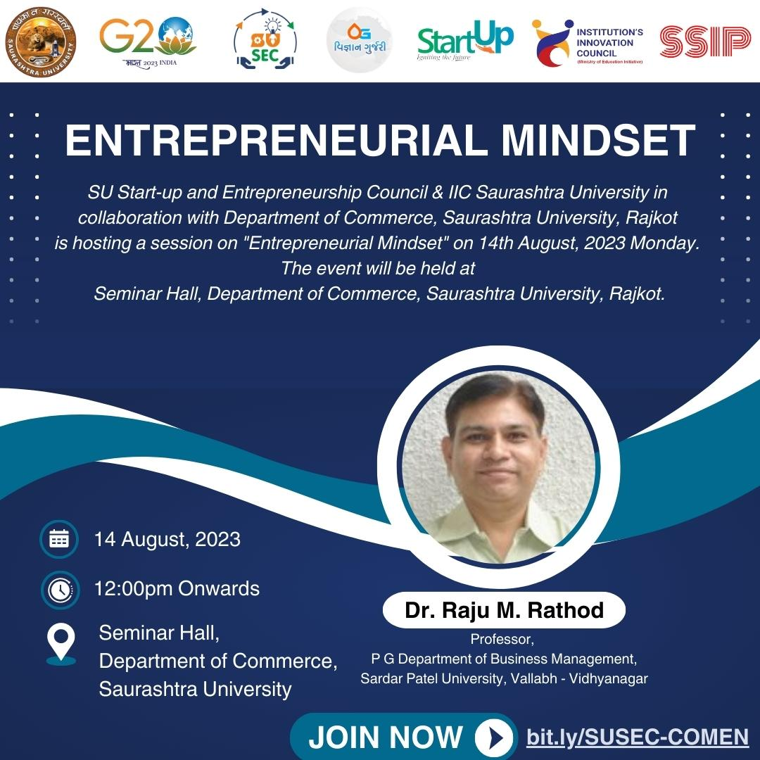

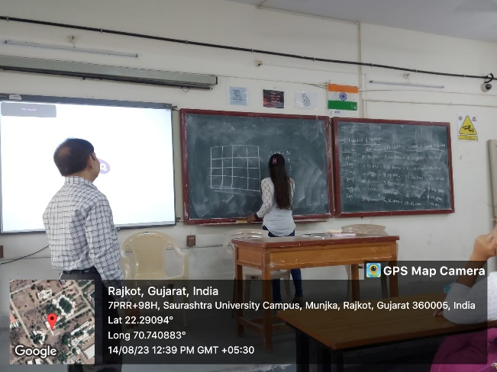
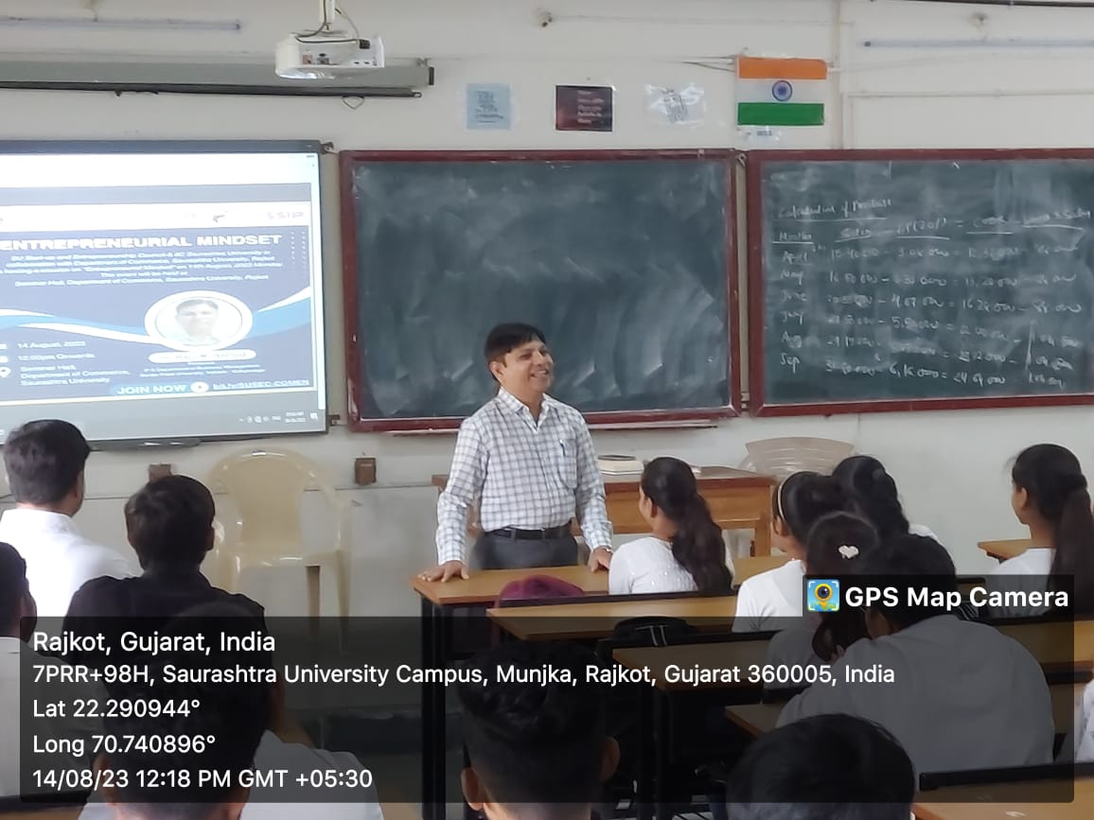
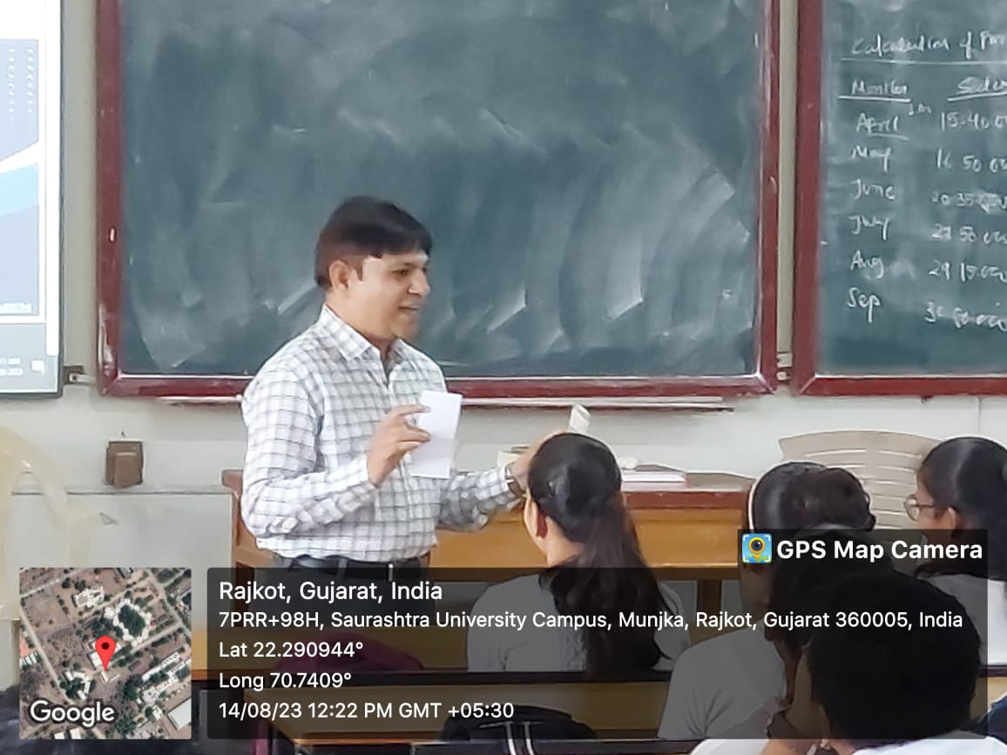
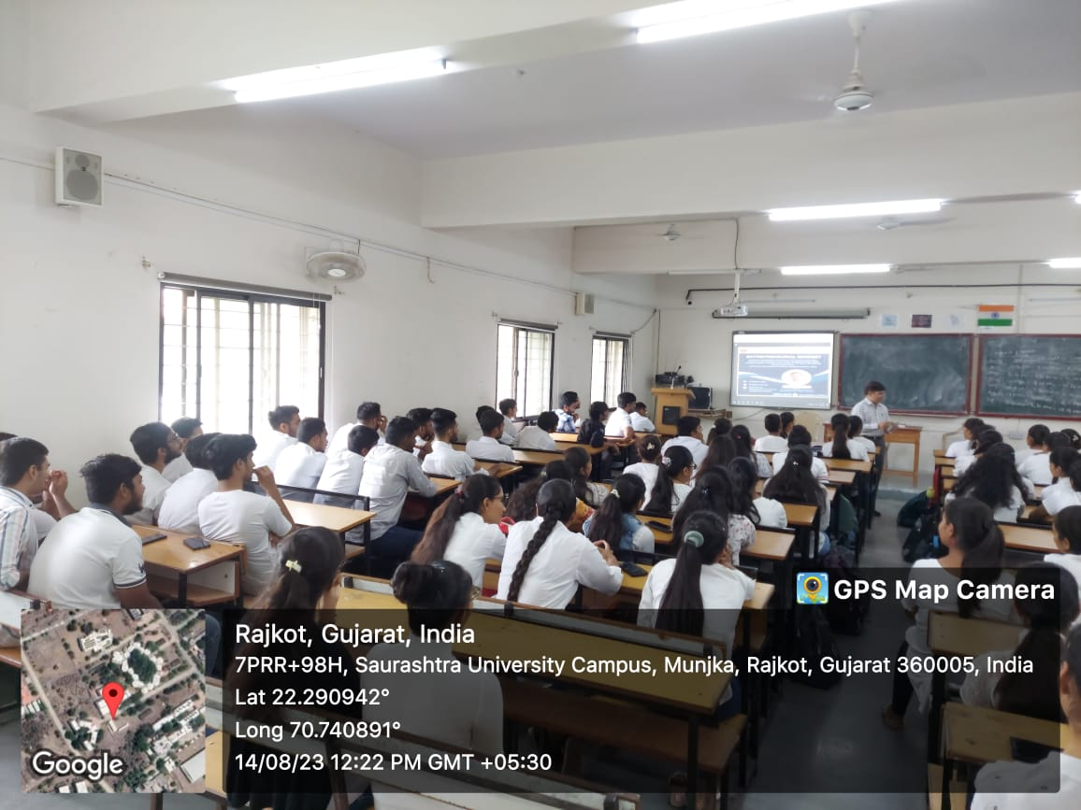
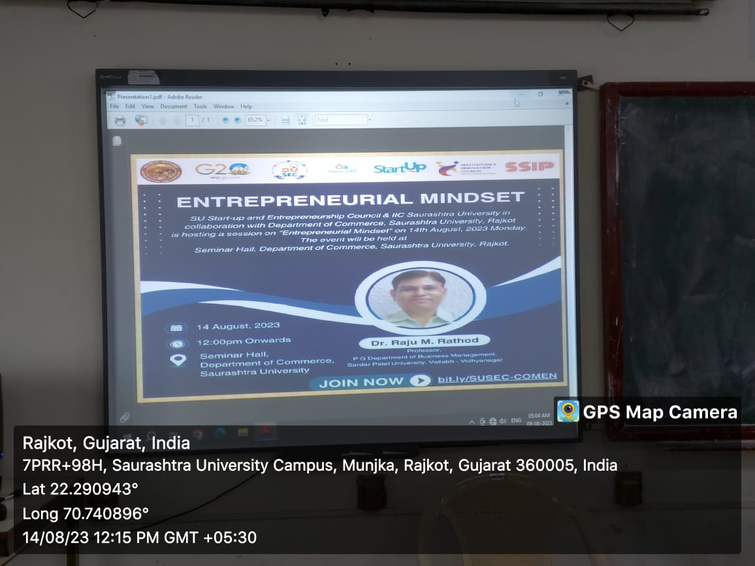
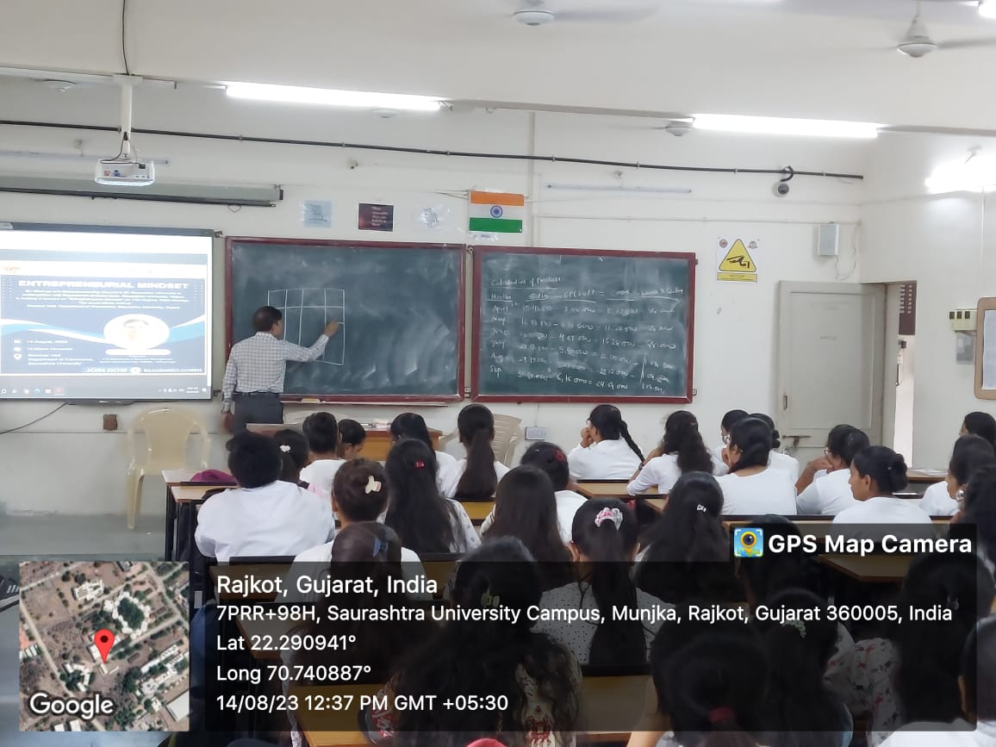

Connect Us:

https://www.linkedin.com/company/susec iic@sauuni.ac.in
https://www.facebook.com/iicsauuni https://bit.ly/SUSECLocation
https://www.instagram.com/susecrajkot https://bit.ly/SUSEC-youtube

